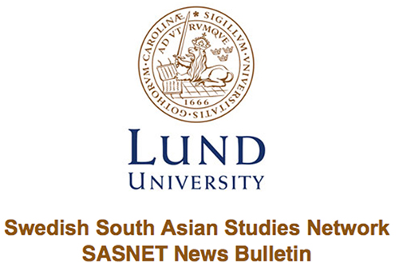
Lund 31 October 2017

Talk on Mobility and Gender in Maldives
On Thursday 23 November 17.15 Phu Doma Lama Ph.D student from the Division of Risk Management and Societal Safety, will hold a talk entitled: “Exploring the consequences of adaptation to changes: The case of mobility and gender in Maldives” at the Center for Middle Eastern Studies (CMES seminar room, Finngatan 16, Lund). The talk is organised by SASA in collaboration with SASNET. Read more…

Seminar on Women’s Agency in Post-Partition Pakistan
On Wednesday 8 November 13-15, Amrita Ghosh will hold a seminar entitled: "Silent Waters: Mapping Silence and Women’s Agency in Post-Partition Pakistan" in room M221 at the Department of Gender Studies (Allhelgona Kyrkogata 14M, Lund). The seminar is organized by the Department of Gender Studies and SASNET. Read more…

Position available as Associate or Full Professor in Asian Humanities
The Department of Asian Languages and Cultures at Northwestern University seeks to appoint a full-time, tenured faculty member in a field in the Asian Humanities beginning in Fall, 2018. Read more…

Interesting lecture on Jewish Identity and Literature in Contemporary India
On Monday 30 October 13.15, Professor Heinz Werner Wessler held a lecture entitled: "Jewish identity and literature in contemporary India" at LUX. The lecture was organised by SASNET and the Centre for Theology and Religious Studies at Lund University. Read more…

Position available as Visiting Assistant Professor of History
The History Department at Denison University invites applications for a one-year visiting position in the history of the Middle East or South Asia to begin in Fall 2018. Read more…

Position available as Assistant Professor in Asian American Studies
The Intercollegiate Department of Asian American Studies at the Claremont Colleges and the Department of Humanities, Social Sciences, and the Arts at Harvey Mudd College invite applications for a tenure-track assistant professor position in Asian American studies, to begin July 1, 2018. Read more…

Call for Papers for Ireland India Institute Conference
The Ireland India Institute is pleased to announce its second Annual Conference on South Asia, to be held from Thursday 26 April to Friday 27 April 2018 at Dublin City University, Ireland. Read more…

Article published in the Times Literary Supplement
SASNET researcher Admir Skodo wrote an article for the Times Literary Supplement entitled "Permanent crisis of legitimacy”. Read more…

SASNET and Sydasien form an exciting collaboration
SASNET and Sydasien form an exciting collaboration that will help disseminate news and research about South Asia to a broader audience. Read more…

Call for Papers for Dissertation Workshop on Ethnography of Connections
Call for paper for dissertation workshop on ethnography of connections to be held 20th November 2017 at the Department of Cross-Cultural and Regional Studies, University of Copenhagen. Read more…

Call for Papers for Panel on Photography in South Asia
Call for papers for the panel on "Producing and consuming photography in South Asia" at the 25th ECSAS conference. ECSAS 2018 is taking place at the École des Hautes Études en Sciences Sociales in Paris, France, from 24 to 27 July 2018. Read more…

Position available as Assistant Professor in Buddhist Studies
Kathmandu University, Centre for Buddhist Studies at Rangjung Yeshe Institute invites applications for a full-time, twelve-month teaching position in Buddhist Studies starting on August 15, 2018. Read more…

Position available as Senior Lecturer in Religious Studies
Religious Studies at Karlstad University needs to recruit a senior lecturer with expertise in Islam, and preferably also in areas such as globalisation, migration, cultural meetings and research experience in empirical quantitative and/or qualitative methods. Read more…

Internship Opportunity at the Nordic Centre in India
The Nordic Centre in India announces a spring internship position for the NCI India Liaison Office for 2018. The deadline for receiving applications is the 31st of October, 2017. Read more…

Successful Planning Grant Application
Dr. Khaleda Gani Dutt and Dr. Liz Adams Lyngbäck were successful in the Planning Grant application submitted to the Forum for Asian Studies at Stockholm University earlier in June this year. Read more…

Dr. Anindita Datta guest researcher at Lund University
Dr. Anindita Datta arrived in Lund as a guest researcher at Lund University for ten days (1-11 October). SASNET provided her with an office during her time in Lund. Read more…

Lecture on Misogyny, Media and Resistances to Genderskaces of Online Hate
On Wednesday 4 October 2017, 10.00-10.20 Andindita Datta held a lecture entitled: "Misogyny, media and resistances to genderscapes of online hate: Of Bharat Mata and Bharat ki Mata”. The lecture was part of the Global Gender Matters Workshop organised by the Department of gender studies. Read more…

SASNET – Swedish South Asian Studies Network
Lund University
(Norlindska villan/Biskopsgatan 5)
Box 201
SE-221 00 Lund
SWEDEN

+46 (0)46 222 73 40 & +46 (0)46 222 36 06

mailto:sasnet@sasnet.lu.se

http://www.sasnet.lu.se/
--------------------------------------------------------------------

