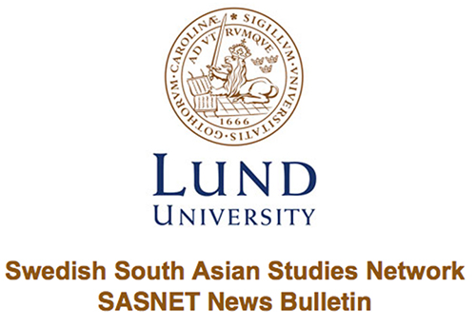
Lund 30 September 2017

The fifth AAS-in-ASIA Conference
The Association for Asian Studies (AAS) and Ashoka University, India invites you to submit organized panels and roundtable proposals (no individual paper proposals accepted) to be presented at the fifth AAS-in-ASIA Conference to be held between the 5th and 8th of July, 2018 at the India Habitat Centre in New Delhi, India. Read more…

Position available as Assistant Professor at IT University of the Punjab
IT University of the Punjab, based at the state of the art Arfa Software Technology Park in Lahore, Pakistan, seeks faculty in its interdisciplinary Centre for History and Politics and its think tank, the Centre for Governance and Policy. Read more…

Position available as Professor of Islamic Studies
The Department of Religious Studies at Bucknell University invites applications for the Josephine Hildreth Detmer & Zareen Taj Mirza Professorship in Islamic Studies, to begin in August 2018. The position can be filled at any rank from tenure-track assistant professor to full professor. Read more…

Position available as Assistant Professor in Hindi
The Department of Asian Studies at the University of Texas at Austin invites applications for a tenure-track position in Hindi at the rank of Assistant Professor, anticipated to start in Fall 2018. Read more…

Position available as Assistant Professor in the History of South Asian Art, Architecture and Visual Culture
The Department of Art History, Visual Art and Theory (AHVA) at the University of British Columbia (UBC), Vancouver, invites applications for a tenure-track appointment at the rank of Assistant Professor specializing in the history of the art, architecture and visual culture of South Asia. Read more…

Call for Applications for IIAS Fellowship
The Collège d’études mondiales of the Fondation Maison des sciences de l’homme in Paris and the International Institute for Asian Studies (IIAS) in Leiden are glad to announce their partnership for a joint post-graduate fellowship, which includes a maximum number of ten months at IIAS, immediately followed by a stay of two months in Paris. Read more…

SUPRA Nordic Scholarship for MA and PhD students Spring 2018
If you are working on a MA or PhD thesis during Spring 2018 and need some inspiration, literature or simply just time to write on your thesis, then NIAS has something to offer: the Nordic Scholarship! The deadline for application is 1 October 2017. Read more…

Successful Movie Screening and Director’s talk
On the 14th of September SASNET and the Museum of Artistic Process and Public Art in Lund, screened the movie "A Million Rivers". The event was well attended and the audience showed great interest at the Q&A session with the award-winning film artist Sarah Singh. Read more…

Call for Papers for Kathmandu Conference on Nepal and the Himalaya
The Seventh Annual Kathmandu Conference on Nepal and the Himalaya organised by Social Science Baha, Association for Nepal and Himalayan Studies, Britain-Nepal Academic Council, Centre for Himalayan Studies-CNRS & Nepal Academic Network (Japan) will be hold 25-27 July 2018 in Kathmandu, Nepal. Read more…

Position available as Postdoc fellow in Colonial History
A one year Postdoc fellowship in colonial history is available at the Department of Cultural Sciences, Linnaeus University in Sweden. The last day of application is 15 October 2017. Read more…

SASNET Researchers held Mini talks
On Friday 15 September, Lund University celebrated its 350th anniversary together with staff and students. To start off the festivities, the USV Centres had a pre-party where SASNET researchers Admir Skodo and Maria Tonini, amongst other USV researchers, held mini talks to highlight the work and research of the USV. Read more…

Position available as Assistant Professor in Modern South Asian History
Northwestern University seeks to appoint a tenure-track assistant professor of modern South Asian history. Read more…

Call for Papers for BASAS Conference 2018
The Exeter South Asia Centre will host the 2018 British Association for South Asian Studies Annual Conference from Wednesday 18th April to Friday 20th April 2018 at the University of Exeter. Read more…

Stockholm Seminar on Language Documentation and Revitalisation in Northern Pakistan
On Thursday 21 September 2017, 15-17 a Higher Seminar in Linguistics with the title "Language documentation and revitalization in northern Pakistan” was held at Stockholm University. Read more…

Position available as Assistant Professor in Religions of South Asia
The Department of Religion at Florida State University invites applications for a full-time, 9-month tenure track Assistant Professor in Religions of South Asia to begin on August 7, 2018. Read more…

SASNET helps develop research projects on South Asia at Lund University
SASNET already has experience in funding research projects after having funded the South Asia Media Project, coordinated by Andreas Mattsson. SASNET has now renewed its commitment to help develop exciting research projects at Lund University. The main goal with this initiative is to help researchers secure external funding for projects on South Asia at Lund University. Read more…

