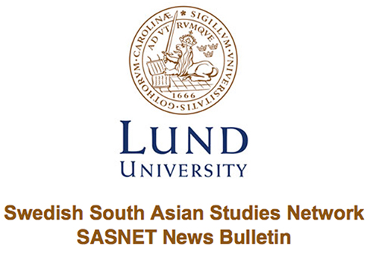
Lund 30 November 2017

Important talk on Mobility and Gender in Maldives
On Thursday 23 November SASA representative Phu Doma Lama Ph.D student from the Division of Risk Management and Societal Safety, will held a talk entitled: “Exploring the consequences of adaptation to changes: The case of mobility and gender in Maldives” at the Center for Middle Eastern Studies. Read more…

Call for Papers for Conference on Courts and Politics in Pakistan
Call for papers for LUMS Annual Conference on Courts and Politics in Pakistan to be held in Lahore on 14-15 March 2018. Submit application before 1 December 2017. Read more…

Position available as Assistant Professor in South Asian History
The Department of History at Reed College invites applications for a Visiting Assistant Professor of History and Humanities, with a specialization in modern or early modern African, Middle Eastern, or South Asian history. Read more…

Call for Papers for Asia in Focus Issue 6
The peer-reviewed journal "Asia in Focus", published online twice a year by NIAS – Nordic Institute of Asian Studies, is now seeking full papers for its sixth issue. The deadline for submissions is 1 February 2018. Read more…

Position available as Assistant Professor in History
The department of History at The Wagner College seeks a tenure-track Assistant Professor in the History of South Asia, Africa or the Middle East and the history of Islam to begin Fall 2018. Read more…

Call for Papers for South Asia Conference in Princeton
The conference on Anxiety and Authority in South Asia will be held on April 6-7, 2018 in Princeton, NJ. Read more…

Call for Papers for South Asia Workshop in Paris
Three years after its debut, the Noria South Asia Program (SAPROG) is pleased to invite you to its third South Asia Research Workshop, organized in collaboration with the National Institute of Eastern Languages and Civilizations (INALCO) and held January 24th at INALCO. Read more…

Position available as Assistant Professor in Persianate Islamic Cultures
The Department of Asian Studies, University of British Columbia (Vancouver campus), invites applications for a tenure-track appointment at the rank of Assistant Professor in Persianate Islamic Cultures of South Asia. Read more…

Position available as Coordinator at ATREE in Bangalore
The Centre for Biodiversity and Conservation (CBC) at Ashoka Trust for Research and the Environment (ATREE) invites applications for a Department of Science and Technology supported project on `Adapting to and mitigating ecological and socio-economic impacts of climate change: Training and capacity building’. Read more…

Position available as Assistant (Amanuens) at SASNET
Applicant should be a student with an international focus on their ongoing education and it is good if the applicant has a particular interest in South Asia. Submit application before 1 December 2017. Read more…

Interesting seminar on Women’s Agency in Post-Partition Pakistan
On Wednesday 8 November Amrita Ghosh held a seminar entitled: "Silent Waters: Mapping Silence and Women’s Agency in Post-Partition Pakistan" at the Department of Gender Studies. The seminar was organized by the Department of Gender Studies and SASNET. Read more…

Andreas Johansson visited New Delhi
In October the director of SASNET, Andreas Johansson visited New Delhi. During this visit he discussed possibilities for collaborations between different institutions in India and Lund University. Read more…
SASNET collaboration with EASAS Doctoral Workshop
On September 22-24, SASNET researcher Maria Tonini joined the 2017 EASAS Doctoral Workshop as a senior scholar. The workshop took place in the breathtaking island of Procida, off the Gulf of Naples, Italy. Read more…

Journalist student Celia Boltes conducted field work in Nepal
Celia Boltes, journalist student at Lund University, received SASA travel grant in the spring of 2017. In September 2017 she travelled to Nepal for a field work. Celia has now returned to Lund and has written a report. Read more…

Resarch Project "Precariousness at Work" funded by Swedish Research Council
SASNET researcher Maria Tonini together with Lisa Eklund, Catarina Kinnvall and Helle Rydström at Lund University will start a Research Project entitled "Precariousness at Work:Workplace Violence against Women Employees in Nordic Companies Outsourced to Asia". The project will be funded by the Swedish Research Council (VR) for three years. Read more…

Lecture on Power, Learning and the Politics of Friendship in Intercultural Fieldwork
On Tuesday 21 November Otso Harju, PhD student in Gender studies at the University of Helsinki, held a lecture on "Power, learning and the politics of friendship in intercultural fieldwork" at Asian Studies. In 2016 Otso Harju conducted a fieldwork for his Master thesis with the help of SASA travel grant. Read more…

SASNET – Swedish South Asian Studies Network
Lund University
(Norlindska villan/Biskopsgatan 5)
Box 201
SE-221 00 Lund
SWEDEN

+46 (0)46 222 73 40 & +46 (0)46 222 36 06

mailto:sasnet@sasnet.lu.se

http://www.sasnet.lu.se/
--------------------------------------------------------------------

